Major Scheduler

Patrick Kelly

Senior Project

October 24th, 2014

**Introduction**

Major Scheduler is an online application for Computer Science students. It will allow students to figure out what courses they still need to take in order to complete their major requirements.

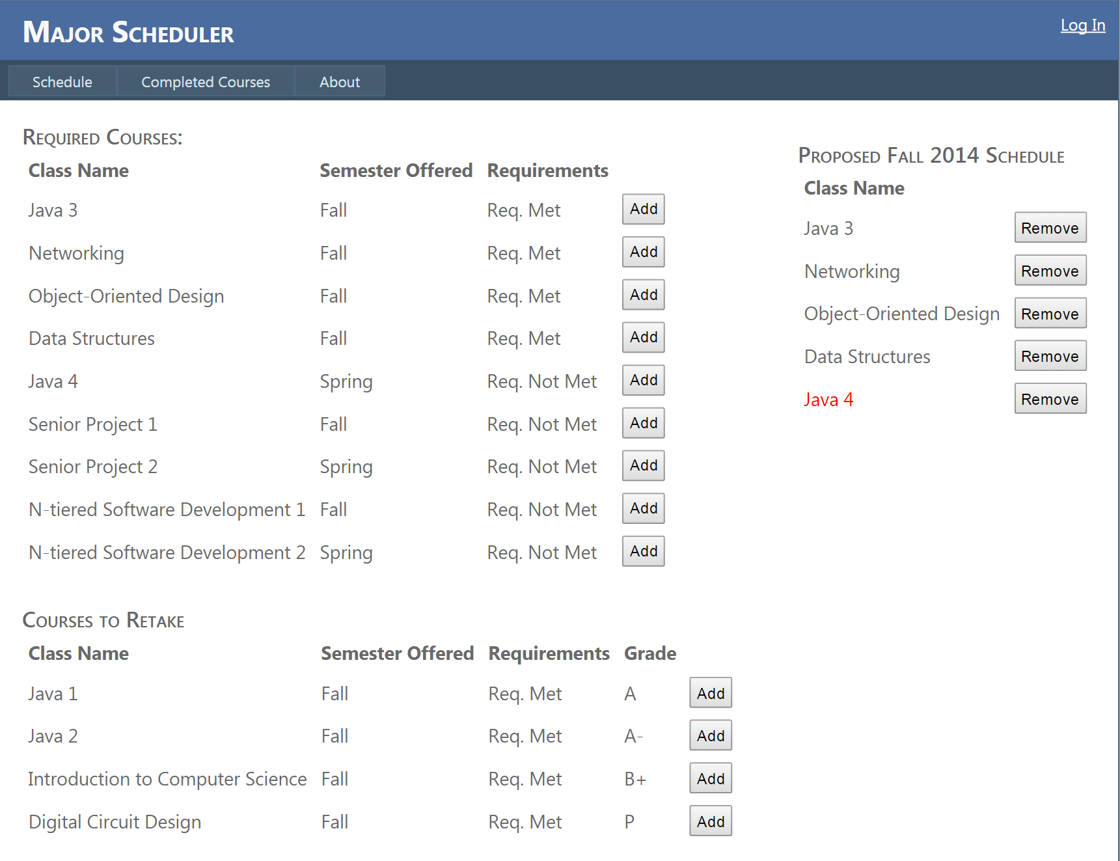

**Description**

Students will be able to choose which Computer Science concentration they belong to. That will create a list of required courses for that student. After signing up the student can choose classes they have already passed. The classes they have passed will update the remaining required courses.

**Login**

This is where all users will login to the application. 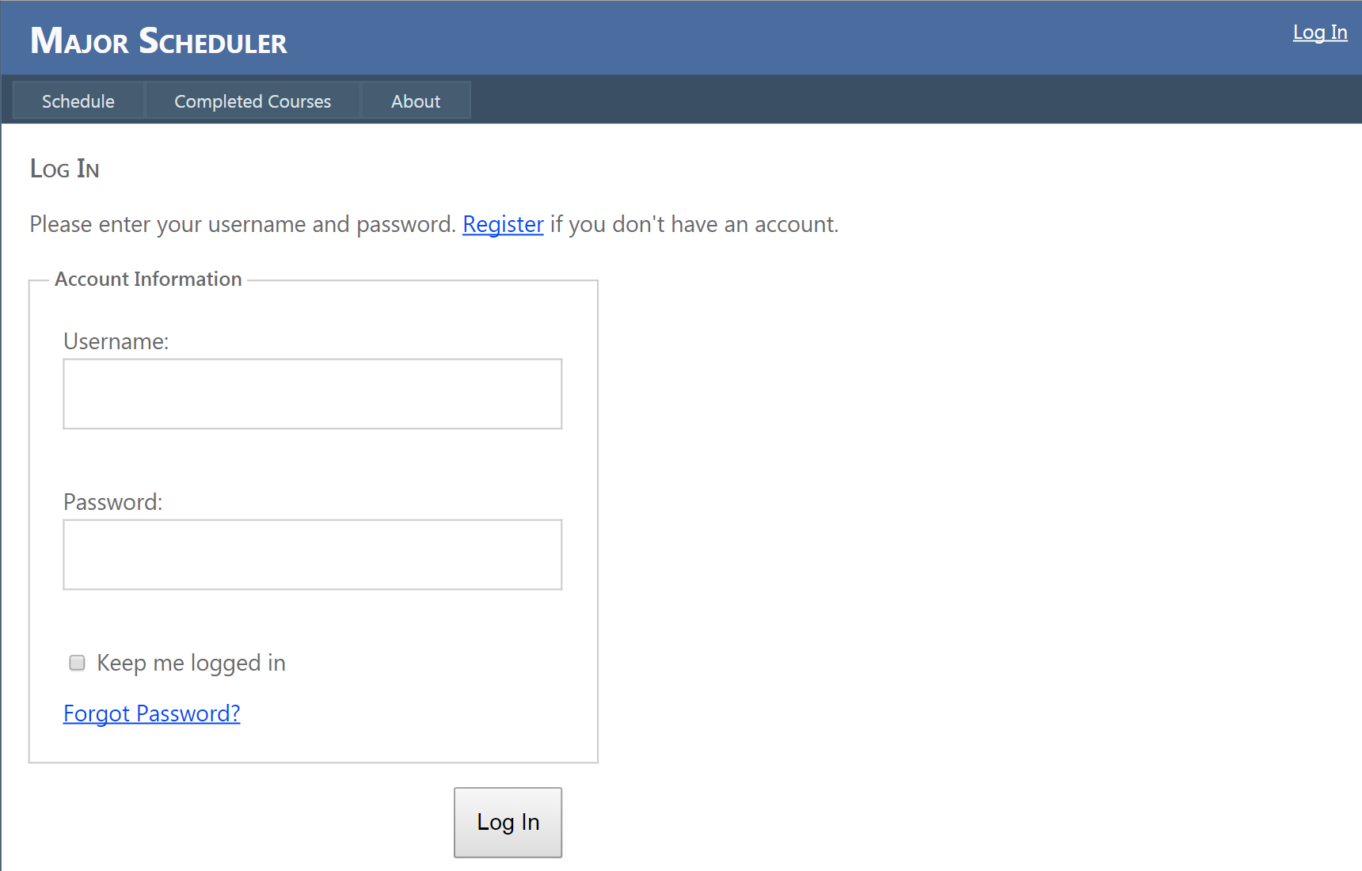

**Forgot Password**

This is where a student will change their password. 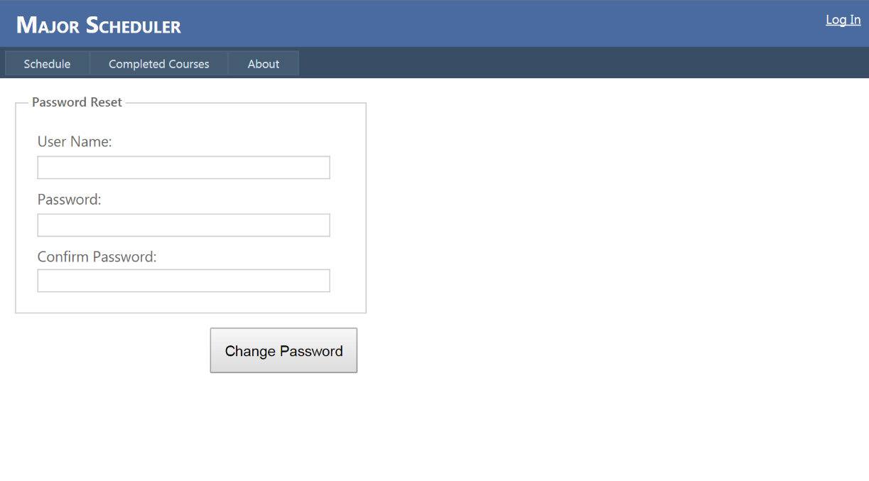

**Registration**

This is where a new student will be created. The password is required to be 10 characters long with one upper-case letter and one symbol ({!@#$%^&()[]{}).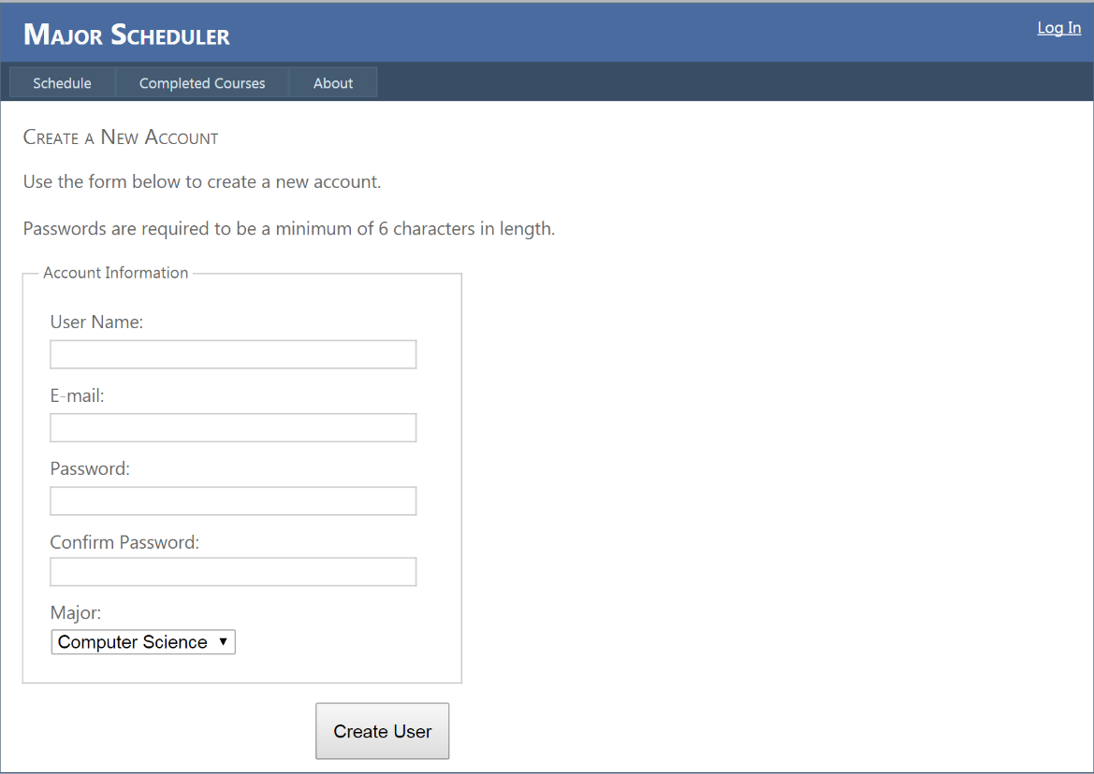

**Completed Courses**

This is where the student will enter their completed required courses. 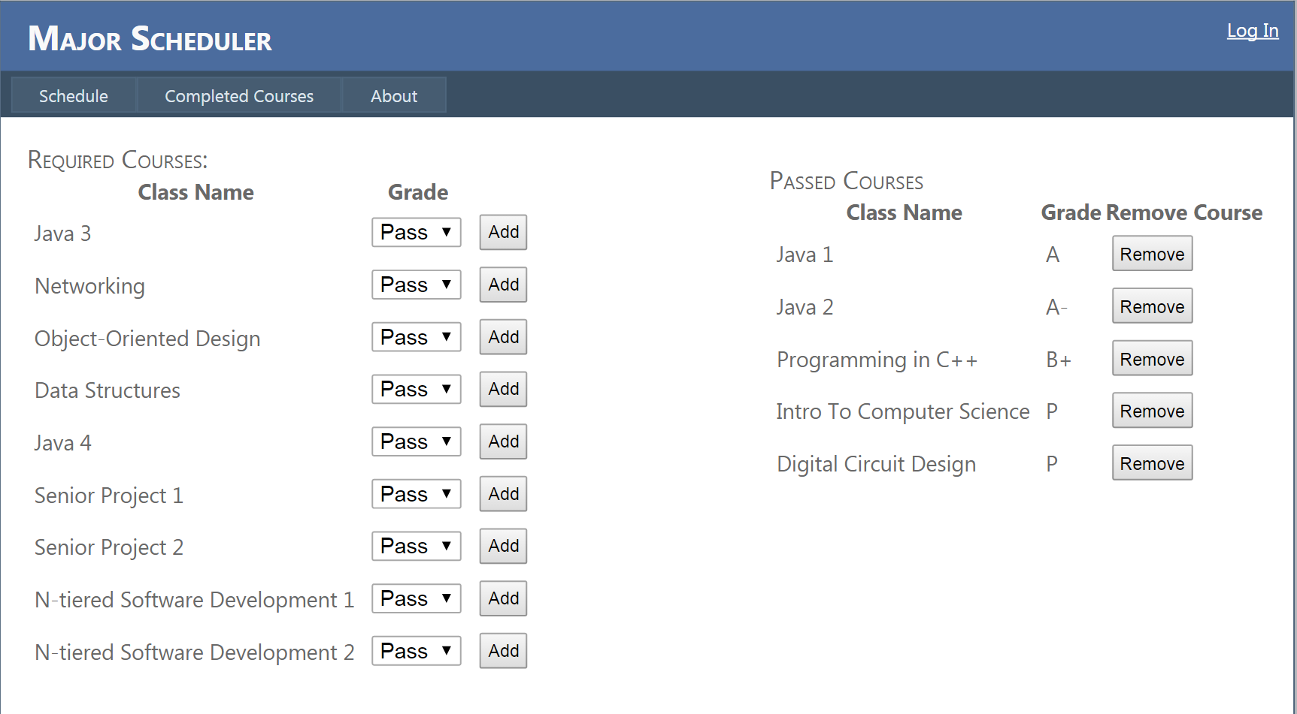

**Schedule**

This is where the student will see their remaining required courses. They can create a list of courses for the upcoming semester. If they haven’t met a requirement for a course they added, it will appear red and an error will display when the mouse hovers over it.

Also, they will see a list of courses that they will need to retake if they did not pass all of the courses they have taken. The feature will later be supported by asking a student what they consider a decent grade, so if they received a C+ but only wanted B- or better, the retake section would include any course with a grade below a B-.

**Timeline**

**Fall**

|  |  |  |  |  |  |  |  |  |  |
| --- | --- | --- | --- | --- | --- | --- | --- | --- | --- |
| Oct. 6 | Oct. 13 | Oct. 20 | Oct. 27 | Nov. 3 | Nov. 10 | Nov. 17 | Nov. 24 | Dec. 1 | Dec 8 |
| Create Actual UI | Redesign UI | Finalized basic UI | Create ERD for Database | Refactor Timeline w/ help from advisor | Begin Rails Development Focus on the UI layout | Cont. prev. | Begin backend design | Cont. prev. | Show application |

**Spring**

|  |  |  |  |  |  |  |  |
| --- | --- | --- | --- | --- | --- | --- | --- |
| Jan. 19 | Jan. 26 | Feb. 2 | Feb. 9 | Feb. 16 | Feb. 23 | Mar. 2 | May 5 |
| Continue Developing back-end | User Tests | User Tests | Redesign UI w/ feedback | Redesign UI w/ feedback | Final Touches | Begin Debugging with user tests (Expand) | Bug Free |